**CHAPTER - 1**

**INTRODUCTION**

B

iometrics are part of the cutting-edge technology. Biometrics are the metrics related to human features. As an emerging technology, biometric systems can add great convenience by replacing passwords, helping law enforcement catch criminals and even in organizations in posting the attendance of an employee. Several types of biometric types are available like Face Recognition, Iris Recognition, Fingerprint Scanner, Voice Recognition, Hand Geometry, Behaviour Characteristics.

* 1. **Importance of Face Recognition**

Face Recognition generally measures the unique patterns of a person’s face by comparing and analysing facial contours. It is not only used in security and law enforcement but also used as a way to authenticate identity and unlock devices like smartphones and laptops. Now-a-days, we are observing many smartphones and laptops having a face recognition system to unlock the device.

* 1. **Problem Definition**

Face Recognition is one of the most widely used feature in many fields. It is used in providing security to data, Fraud detection of Passports and Visas, Track attendance, detecting the criminals etc.

Face Recognition system is being used by some organization to track the attendance of the employees. The system collects and records the facial fine points of the employees in the database. Once the process is done, the employee only needs to look at the camera and the attendance is automatically marked in the face recognition attendance system.

The project develops a novel CNN model which is used for Face recognition. The face that is detected and recognized using this CNN model will be provided the attendance based on the time at which the person faces the camera.

* 1. **Objective**

The main objective of the project is to build a custom CNN model that can recognize the faces and post the appropriate attendance into the database for the designated periods based on the timings of the college hours.

**CHAPTER – 2**

**LITERATURE SURVEY**

T

his chapter gives a brief description of various research papers related to the Computer Vision problems. The mentioned research papers are studied in order to understand the advantages, disadvantages and the limitations of the various proposed CNN architectures for Facial Recognition.

**2.1 Study of Research Papers**

**Title: Understanding of a Convolutional Neural Network**

The term Deep Learning or Deep Neural Network refers to Artificial Neural Networks (ANN) with multi layers. Over the last few decades, it has been considered to be one of the most powerful tools, and has become very popular in the literature as it is able to handle a huge amount of data. The interest in having deeper hidden layers has recently begun to surpass classical methods performance in different fields; especially in pattern recognition. One of the most popular deep neural networks is the Convolutional Neural Network (CNN). It takes this name from mathematical linear operation between matrixes called convolution.

CNN have multiple layers; including convolutional layer, non-linearity layer, pooling layer and fully connected layer and all those layers have been explained. The convolutional and fully- connected layers have parameters but pooling and non-linearity layers don't have parameters. The CNN has an excellent performance in machine learning problems.

Specially the applications that deal with image data, such as largest image classification data set (Image Net), computer vision, and in natural language processing (NLP) and the results achieved were very amazing. This paper will explain and define all the elements and important issues related to CNN, and explain the effect of each parameter on performance of the network. In addition, we will also state the parameters that effect CNN efficiency. The dataset used in the paper is CIFAR-10 dataset.

**Title: A Survey of the Recent Architectures of Deep Convolutional Neural Networks**

Deep Convolutional Neural Network (CNN) is a special type of Neural Networks, which has shown exemplary performance on several competitions related to Computer Vision and Image Processing. Some of the exciting application areas of CNN include Image Classification and Segmentation, Object Detection, Video Processing, Natural Language Processing, and Speech Recognition.

The powerful learning ability of deep CNN is primarily due to the use of multiple feature extraction stages that can automatically learn representations from the data. The availability of a large amount of data and improvement in the hardware technology has accelerated the research in CNNs, and recently interesting deep CNN architectures have been reported. Several inspiring ideas to bring advancements in CNNs have been explored, such as the use of different activation and loss functions, parameter optimization, regularization, and architectural innovations. However, the significant improvement in the representational capacity of the deep CNN is achieved through architectural innovations. Notably, the ideas of exploiting spatial and channel information, depth and width of architecture, and multi-path information processing have gained substantial attention. Similarly, the idea of using a block of layers as a structural unit is also gaining popularity.

CNNs are one of the best learning algorithms for understanding image content and have shown exemplary performance in image segmentation, classification, detection, and retrieval related tasks. CNN, with the automatic feature extraction ability, reduces the need for a separate feature extractor**.** During training, CNN learns through backpropagation algorithm, by regulating the change in weights according to the target. Optimization of an objective function using a backpropagation algorithm is similar to the response-based learning of the human brain. In 2015, the concept of skip connections introduced by ResNet for the training of deep CNNs gained popularity. Afterward, this concept was used by most of the succeeding networks, such as Inception-ResNet, Wide ResNet, ResNeXt, etc., CNN has not only shown good performance on images but also on 1D-data. The use of 1D-CNN as compared to other ML methods is becoming popular because of its good feature extraction ability. The major challenge with CNN is that deep CNNs are generally like a black box and thus may lack in interpretation and explanation. Therefore, sometimes it is difficult to verify them. Data augmentation can help CNN in learning diverse internal representations, which ultimately may lead to improved performance.

**Title: When face recognition meets with deep learning: an evaluation of convolutional neural networks for face recognition**

Deep learning, in particular Convolutional Neural Network (CNN), has achieved promising results in face recognition recently. However, it remains an open question: why CNNs work well and how to design a ‘good’ architecture. Existing studies tend to focus on reporting CNN architectures that work well for face recognition rather than investigate the reason.

This paper conducts an extensive evaluation of CNN-based face recognition systems (CNNFRS) on a common ground to make the work easily reproducible. The public database LFW (Labelled Faces in the Wild). This paper proposes three CNN architectures which are the first reported architectures trained using LFW data. The three architectures proposed are CNN-S, CNN-M, CNN-L. Different CNN architectures including number of filters and layers are compared. It also evaluates the face recognition performance using features from different layers: pooling, fully connected and softmax layers. It concluded that the features from softmax layer perform slightly better than those from the most widely used fully connected layer.

**Title: Attendance and Security System Based on Building Video Surveillance**

The attendance system plays a very important role in the modern enterprise’s operation, and the security of the building has always been a matter of concern to the people. Based on networked surveillance video, this paper integrates the attendance and security functions and fuses video image processing, deep learning, and face recognition to design an intelligent attendance and security system. It proposes a sliding average method to identify person’s identities.

The experimental results verify the effectiveness of the proposed method. The false reject rate (FRR) reaches 0.51%, the false accept rate (FAR) reaches 2.52%, and the correct identification rate reaches 98.85%. The system is applied to some video surveillance areas, with advantages of nonintrusive, passive attendance and multiple persons’ attendance at the same time. This paper uses the MTCNN [9] algorithm which is widely used for human face detection. Like YOLO, it treats the detection problem as a regression problem and uses the convolution network to train optimize classification and object locations. First built the image pyramid, and then designed three CNN models: P-Net, R-Net, and O-Net to perform cascading prediction to improve the accuracy, defined the label of the image, and designed cross-entropy loss and Euclidean distance loss function. The position of the face and the five key points of the face are obtained by training.

This paper combines the network structure design of AlexNet and Inception to construct a convolutional neural network for face recognition and classification, proposes a method based on sliding average to improve the accuracy of recognition, and builds face dataset in actual scenes, verifying the effectiveness of the algorithm.

**Title: University Classroom Attendance Based on Deep Learning**

Attendance is an important part of classroom evaluation. This paper develops a university classroom automatic attendance system by integrating two deep learning algorithms MTCNN face detection and Center-Face face recognition.

A large number of experimental results show that:

* The system can record such three violations of classroom discipline for automatic attendance, that is absence, lateness and leaving early. An attendance table about all students learning status after class is immediately recorded.
* The system identifies faces very fast needing only 100 milliseconds to one frame and obtaining a high accuracy. This face recognition model has an accuracy rate of 98.87% and the true positive rate under 1/1000 the false positive rate is 93.7% on LFW. Based on the deep learning, MTCNN combines face detection with face landmark and Center Face algorithm based on deep learning to achieve non-interference automatic and whole process of class attendance. It also can give absence, lateness, leaving early the three classroom attendance indicators. It’s a very promising university classroom attendance technology.

**2.2 Existing System**

The existing system for Face Recognition uses some built-in datasets and some built-in architectures. Even though some custom data sets have been prepared and used they have been using the architectural models that have been already present. Some of the models that have been used in the existing systems are:

* Local Binary Histogram Pattern (LBHP)
* Fischer Face Recognition
* Eigen Face Recognition

**1. Local Binary Histogram Pattern (LBHP)**

In the LBHP approach for texture classification, the occurrences of the LBHP codes in an image are collected into a histogram. The classification is then performed by computing simple histogram similarities. However, considering a similar approach for facial image representation results in a loss of spatial information and therefore one should codify the texture information while retaining also their locations. One way to achieve this goal is to use the LBHP texture descriptors to build several local descriptions of the face and combine them into a global description

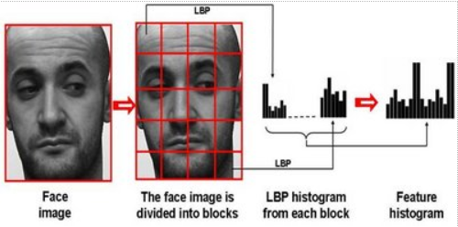

Figure 2.1: Face Description with Local Binary Patterns

The facial image is divided into local regions and LBHP texture descriptors are extracted from each region independently. The descriptors are then concatenated to form a global description of the face, as shown in Fig. 2.1

This histogram effectively has a description of the face on three different levels of locality: the LBHP labels for the histogram contain information about the patterns on a pixel-level, the labels are summed over a small region to produce information on a regional level and the regional histograms are concatenated to build a global description of the face.

**2. Fischer Face Recognition**

The input generally given to a face recognition system is always an image or video stream and the output is an identification of the subject or subjects that appear in the image or video.

Fisher Face is one of the popular algorithms used in face recognition, and is widely believed to be superior to other techniques, such as eigenface because of the effort to maximize the separation between classes in the training process. Image recognition using Fisher Face method is based on the reduction of face space dimension using Principal Component Analysis (PCA) method, then apply Fisher's Linear Discriminant (FLD) method or also known as Linear Discriminant Analysis (LDA) method to obtain feature of image characteristic.



Figure 2.2: Fischer Faces

The Fischer Face method learns a class-specific transformation matrix, so they do not capture illumination as obviously as the Eigen faces method. The Discriminant Analysis instead finds the facial features to discriminate between the persons. The Fischer Face is especially useful when facial images have large variations in illumination and facial expressions. The example of Fischer face representation is illustrated in Figure 2.2.

**3. Eigen Face Recognition**

An eigen face is the name given to a set of eigen vectors when used in computer vision problem of human face recognition. The eigenvectors are derived from the covariance matrix of the probability distribution over the high-dimensional vector space of face images. The eigenfaces themselves form a basis set of all images used to construct the covariance matrix. This produces dimension reduction by allowing the smaller set of basis images to represent the original training images. Classification can be achieved by comparing how faces are represented by the basis set.



Figure 2.3: Eigen Faces

A set of eigenfaces can be generated by performing a mathematical process called Principal Component Analysis (PCA) on a large set of images depicting different human faces. Informally, eigenfaces can be considered a set of "standardized face ingredients", derived from statistical analysis of many pictures of faces. Any human face can be considered to be a combination of these standard faces. For example, one's face might be composed of the average face plus 10% from eigen face 1, 55% from eigen face 2, and even −3% from eigen face 3. Remarkably, it does not take many eigen faces combined together to achieve a fair approximation of most faces. The example of Fischer face representation is illustrated in Figure 2.3.

* 1. **Proposed System**

The project proposes a pipeline to build a Deep Learning model for Face Recognition which is motivated by the state-of-the-art architectures in Computer Vision. The contributions of the project are:

* Develops a novel Deep Learning model to detect and recognize the human faces.
* Develops a web application to post the attendance using the novel Deep Learning model developed.
* The process flow to develop a new face dataset is proposed which is furtherly used to train the Deep Learning model.

The result of the project will be the provision of attendance for the corresponding period after recognising the face based on the time at which the person’s face has been captured.

**CHAPTER - 3**

**ANALYSIS**

I

t is essential to understand the requirements of the project which plays a crucial role in developing and achieving or meeting the desired goal. The Hardware Requirements and the Software Requirements of the project for developing and reproducing the results of the projects are discussed in detail.

**3.1 Hardware Requirements**

To develop a Deep Learning is a hard task without proper hardware support. To overcome this issue, the development of deep learning model is done in the google colaboratory platform. Which provides high end hardware support to develop the machine learning and deep learning models. The configuration of the CPU and GPU based on the google colaboratory are:

* *Graphical Processing Unit (GPU)* used is 1X TeslaK80 with 2496 CUDA cores, 12GB GDDR5 VRAM
* *Central Processing Unit (CPU)* used if 1X single core hyper threaded Xeon Processors, 45MB Cache with 12.6 GB RAM and 320GB disk.

**3.2 Software Requirements**

These are the essential software requirements that are necessary to build and deploy the Deep Learning model and the web application. The windows10 operation system with intel i5 7th processor having 8GB RAM is used and the installation on the programming language and the important libraries that are used to develop the project are addressed below:

1. **Python**

Python is an interpreted, object-oriented, high-level programming language with dynamic semantics. Its high-level built in data structures, combined with dynamic typing and dynamic binding, make it very attractive for Rapid Application Development, as well as for use as a scripting or glue language to connect existing components together. Python supports modules and packages, which encourages program modularity and code. Python 3 is used to develop the project. The detailed explanation of python 3 installation procedure can be accessed through the official documentation of python at (<https://docs.python.org/3/using/index.html>).

1. **TensorFlow**

TensorFlow is an open source library for numerical computation and large-scale machine learning. TensorFlow bundles together a slew of machine learning and deep learning models and algorithms and makes them useful by way of a common metaphor. It uses Python to provide a convenient front-end API for building applications with the framework, while executing those applications in high-performance C++.

The TensorFlow 2.2.0 version is used throughout the project. Here is the official site for installation instructions (<https://www.tensorflow.org/install/>).

1. **Keras**

Keras is one of the leading high-level neural networks APIs. It is written in Python and supports multiple back-end neural network computation engines. The Keras 2.2.5 version is used throughout the project to develop the deep learning models. The installation instructions can be accessed using the link (<https://keras.io/#installation>).

1. **SciKit - Learn**

Scikit-learn is probably the most useful library for machine learning in Python. The sklearn library contains a lot of efficient tools for machine learning and statistical modeling including classification, regression, clustering and dimensionality reduction. The command pip install sklearn can be used to install the libraries.

1. **Pandas**

Pandas is a fast, powerful, flexible and easy to use open source data analysis and manipulation tool, built on top of the Python programming language. The pandas 1.0.3 is used in the entire project and the command to install the package is pip install pandas == 1.0.3.

1. **Matplotlib**

Matplotlib is a collection of command style functions that make matplotlib work like MATLAB. Each pyplot function makes some change to a figure: e.g., creates a figure, creates a plotting area in a figure, plots some lines in a plotting area, decorates the plot with labels, etc. The 3.2.1 version is used in the project and the command to install the package is pip install matplotlib == 3.2.1.

1. **Jupyter**

The Jupyter Notebook is an open source web application that you can use to create and share documents that contain live code, equations, visualizations, and text. The version 1.0.0 is used in the project and the command to install the package is pip install jupyter == 1.0.0.

1. **Flask**

Flask is a micro web framework written in Python. It is classified as a micro framework because it does not require particular tools or libraries. It has no database abstraction layer, form validation, or any other components where pre-existing third-party libraries provide common functions. The version 1.0.2 is used in the project and the command to install the package is pip install flask == 1.0.2.

**CHAPTER – 4**

**DESIGN**

T

he UML diagrams are the way of visualizing a software program using a collection of diagrams. The notation has evolved from the work of Grady Booch, James Rumbaugh, Ivar Jacobson, and the Rational Software Corporation to be used for object-oriented design, but it has since been extended to cover a wider variety of software engineering projects.

**4.1 Purpose of UML Diagrams**

With the use of UML, an appropriate UML development tool, and an application process or methodology, the design and refining of the application is shifted from the development phase to an analysis and design phase. This reduces risk and provides a vehicle for testing the architecture of the system before coding begins. The analysis and design overhead will eventually pay dividends as the system has been user driven, documented and when it’s time to start developing, many UML tools will generate skeleton code that will be efficient, object oriented and promote re-use.

Furthermore, the use of UML will help:

* The communication of the desired structure and behaviour of a system between analysts, architects, developers, stakeholders and users.
* The visualization and control of system architecture
* Promote a deeper understanding of the system, exposing opportunities for simplification and re-use
* Manage risk

**4.2 Diagrams**

There are eight most widely used UML diagrams. They are:

* Class Diagram
* Use Case Diagram
* Sequence Diagram
* Activity Diagram
* Collaboration Diagram
* Deployment Diagram
* State Chart Diagram
* Component Diagram

**1. Class Diagram:**

Class diagram is a static diagram. It represents the static view of an application. Class diagram is not only used for visualizing, describing, and documenting different aspects of a system but also for constructing executable code of the software application.

Class diagram describes the attributes and operations of a class and also the constraints imposed on the system. The class diagrams are widely used in the modelling of object-oriented systems because they are the only UML diagrams, which can be mapped directly with object-oriented languages.

**2. Use Case Diagram:**

Use case diagrams consists of actors, use cases and their relationships. The diagram is used to model the system/subsystem of an application. A single use case diagram captures a particular functionality of a system.

It is defined and created from use case analysis. Its purpose is to present a graphical overview of the functionality provided by a system in terms of actors, their goals (represented as use cases), and any dependencies between those use cases. The main purpose of a use case diagram is to show what system functions are performed for which actor. Hence to model the entire system, a number of use case diagrams are used.

**3. Sequence Diagram:**

A sequence diagram simply depicts interaction between objects in a sequential order i.e. the order in which these interactions take place. We can also use the terms event diagrams or event scenarios to refer to a sequence diagram. Sequence diagrams describe how and in what order the objects in a system function. These diagrams are widely used by businessmen and software developers to document and understand requirements for new and existing systems.

**4. Activity Diagram:**

Activity Diagrams are generally used to illustrate the flow of control in a system. We can also use an activity diagram to refer to the steps involved in the execution of a use case. We model sequential and concurrent activities using activity diagrams. So, we basically depict workflows visually using an activity diagram. It focuses on condition of flow and the sequence in which it happens. We describe or depict what causes a particular event using an activity diagram.

**5. Collaboration Diagram**

Collaboration diagrams which are also known as Communication Diagrams are used to show how objects interact to perform the behaviour of a particular use case, or a part of a use case. Along with sequence diagrams, collaboration are used by designers to define and clarify the roles of the objects that perform a particular flow of events of a use case.  They are the primary source of information used to determining class responsibilities and interfaces.

**6. Deployment Diagram:**

A deployment diagram is a UML diagram type that shows the execution architecture of a system, including nodes such as hardware or software execution environments, and the middleware connecting them.

Deployment diagrams can be used to model the hardware topology of a system, model the embedded system, model the hardware details for a client/server system, model the hardware details of a distributed application and even in forward, reverse engineering.

**7. State Chart Diagram**

A State Chart diagram describes a state machine. State machine can be defined as a machine which defines different states of an object and these states are controlled by external or internal events.

State Chart diagrams are useful to model the reactive systems. Reactive systems can be defined as a system that responds to external or internal events.

State Chart diagram describes the flow of control from one state to another state. States are defined as a condition in which an object exists and it changes when some event is triggered. The most important purpose of State Chart diagram is to model lifetime of an object from creation to termination.

**8. Component Diagram:**

In the Unified Modelling Language, a component diagram depicts how components are wired together to form larger components and or software systems. They are used to illustrate the structure of arbitrarily complex systems. It does not describe the functionality of the system but it describes the components used to make those functionalities.

Component diagrams are very important from implementation perspective. It can be mostly used in modelling the components of a system, modelling the database schema, executables of an application and even system’s source code.

**4.3 Sequence Diagram**

In this sequence diagram we have four objects namely user, web application, CNN model and a database.

* Initially the user runs the web application and the web application gives an access and opens a camera to capture the images.
* Then the camera extracts the faces and gives it to CNN model.
* Then the CNN model pre-processes the captured images and predicts the class of the image.
* Based on prediction of the class, the attendance is posted into the database for the designated periods based on the timings of the college hours and the details and status of attendance is displayed on the output screen.

The Figure 4.1 represents the process flow in the form of Sequence Diagram.

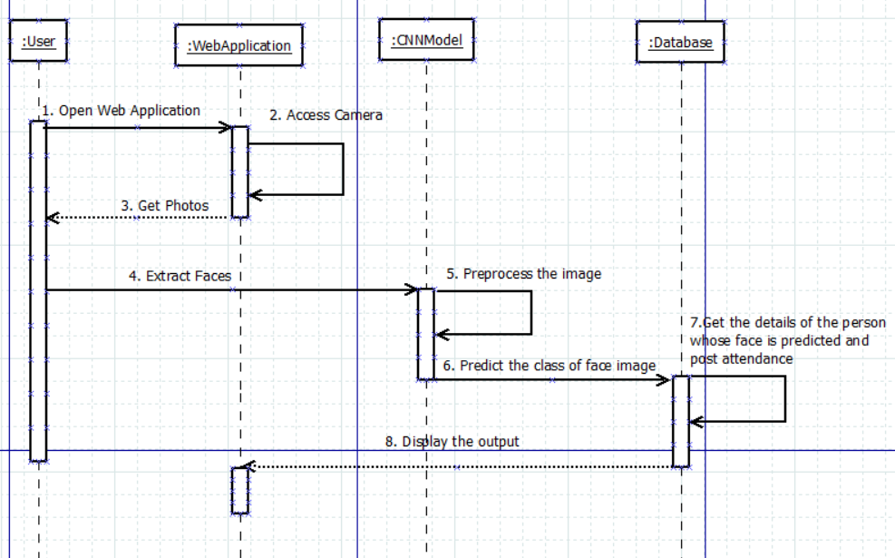

Figure 4.1: Sequence Diagram

**CHAPTER - 5**

**DATA COLLECTION AND ANALYSIS**

T

he data for Deep Learning is a key input to model that comprehend from such data and learn the features for future prediction. Although, various aspects come during the deep learning model development, without which various crucial tasks cannot be accomplished. In other words, data is a backbone of entire model development without that it is not possible to train a machine that learns from humans and predict for humans.

So, the project also focuses on the creating the data set of human faces for face recognition. The data is collected through an automated program which takes the faces of the humans, stores and transforms into a dataset. The dataset contains the human faces at different *lighting conditions* and *angles*.

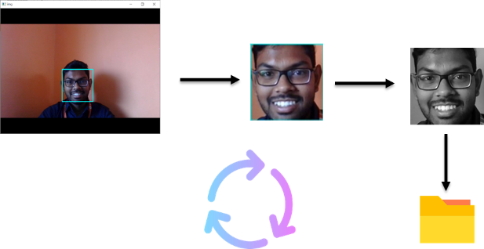

Figure 5.1: Data Collection

The Figure 5.1 illustrates the process flow of the data collection as follows:

* Identify the location of face in the video frame.
* Extract the face image and convert into gray scale image.
* Attach the label w.r.t to the class of the image and write into a csv file.



Figure 5.2: Images w.r.t Classes

The Figure 5.2 illustrates the samples of the data based on the classes.

**5.1 Data Augmentation**

Data Augmentation is a strategy that enables practitioners to significantly increase the diversity of data available for training models, without actually collecting huge data. It can be done by using techniques such as cropping, padding, and horizontal flipping are commonly used to train large neural networks. In order to achieve high accuracy, large volume of training data is required. Hence, data augmentation technique is used to generate new samples by manipulating the existing data. In the current work, synthetic images are being generated randomly, by applying the following operations:

* Zoom
* Shear
* Height shift
* Rotation
* Width shift

Figure 5.3: Data Augmentation

The Figure 5.3 illustrates the samples of the data before and after using data augmentation.

**5.2 Data Visualization and Analysis**

Data visualization is a technique that uses an array of static and interactive visuals within a specific context to help people understand and make sense of large amounts of data. The data is often displayed in a story format that visualizes patterns, trends and correlations that may otherwise go unnoticed. It is often helps to understand the patterns in the data. Principal Component Analysis (PCA) is used in order to visualise the data in different forms. Here are some of the different visualisations to understand the data.

**Pair plot** is used to understand the best set of features to explain a relationship between two variables or to form the most separated clusters. It also helps to form some simple classification models by drawing some simple lines or make linear separation in our dataset. A Simple 2D plots is used to understand the relationship or pattern between two variables or dimensions in the dataset as shown in Figure 5.4. Where PC means Principle Component.

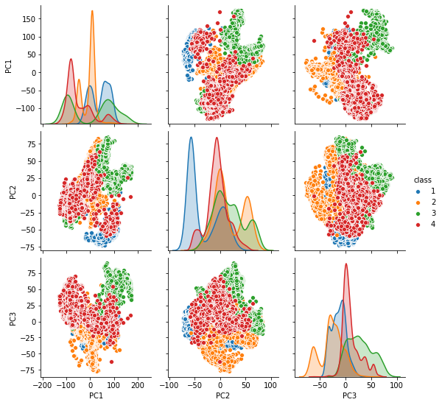

Figure 5.4: Pair Plot of the data

**Scatter plots** are important in statistics because they can show the extent of correlation, if any, between the values of observed quantities or phenomena (called variables). If no correlation exists between the variables, the points appear randomly scattered on the coordinate plane. If a large correlation exists, the points concentrate near a straight line. The Figure 5.5 shows the three-dimensional scatter plot using the PCA.

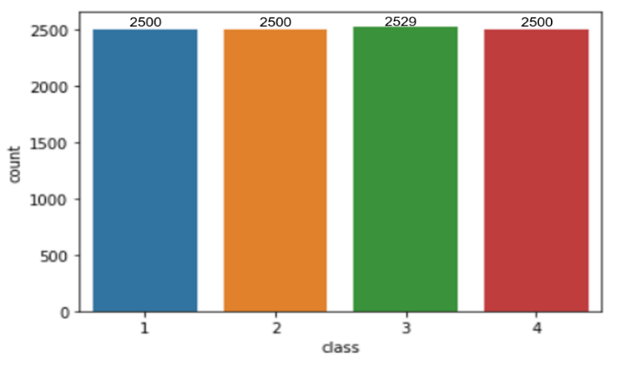

Figure 5.6: Count Plot



Figure 5.5: Scatter Plot

The **Count Plot** is used to understand the samples in the data with respect to class and the visualization is shown in Figure 5.6.

**Correlation** is usually defined as a measure of the linear relationship between two quantitative variables (e.g., height and weight). Often a slightly looser definition is used, whereby correlation simply means that there is some type of relationship between two variables. This post will define positive and negative correlation, provide some examples of correlation, explain how to measure correlation and discuss some pitfalls regarding correlation.

When the values of one variable increase as the values of the other increase, this is known as positive correlation (see the image below). When the values of one variable decrease as the values of another increase to form an inverse relationship, this is known as negative correlation. The Figure 5.7 represents the correlation between the three principal components (PC).

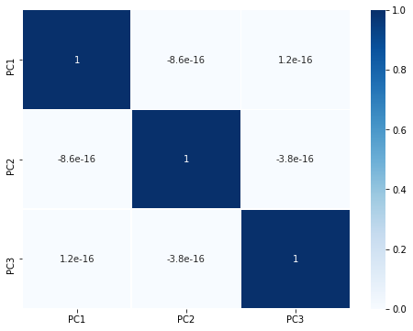

Figure 5.7: Correlation Between the Principal Components

**CHAPTER - 6**

**Developing CNN Model**

T

he advancements in Computer Vision with Deep Learning has been constructed and perfected with time, primarily over one particular algorithm a Convolutional Neural Network. A Convolutional Neural Network (CNN) is a Deep Learning algorithm which can take in an input image, assign importance (learnable weights and biases) to various aspects/objects in the image and be able to differentiate one from the other.

* 1. **Role of CNN in Computer Vision**

Computer Vision is an interdisciplinary field of science that aims to make computers process, analyse images and videos and extract details in the same way a human mind does. Earlier computer vision was meant only to mimic human visual systems until we realized how AI can augment its applications and vice versa.

Convolutional Neural Networks has been playing a significant role in many applications including surveillance, object detection, object tracking, healthcare, retail, banking, automobile, financial services, etc. Extensive research is recorded for face recognition using CNNs, which is a key aspect of surveillance applications. The rise of deep learning has enabled Deep Neural Networks (DNN) to achieve greater results in pattern recognition and Convolutional Neural Network (CNN) is a class of DNN which is most commonly applied to analysing visual imagery. It is used not only in Computer Vision but also for text classification in Natural Language Processing (NLP).

CNNs performs well when compared to the feed forward neural networks as it uses less number of parameters for computation and also it uses different layers to learn the patterns. CNNs are used for a wide range of image-related tasks such as image classification, object detection/localization, image generation, visual question answering, image segmentation, etc. The availability of the computation power at a lower cost has enabled a path to solve a lot of problems which have been considered as virtually a hard task for the computers for the past few years.

Many architectures are created to solve computer vision tasks and some of the widely popular CNN architectures are AlexNet (2012), VGG-16 (2014), Inception-v1 (2014), Inception-v3 (2015), ResNet-50 (2015), Xception (2016), Inception-v4 (2016), Inception-ResNet-v2 (2016), ResNeXt-50 (2017).

* 1. **Essential Layers to Develop CNN**

The Convolutional Neural Networks CNNs have several different filters/kernels consisting of trainable parameters which can convolve on a given image spatially to detect features like edges and shapes. These high number of filters essentially learn to capture spatial features from the image based on the learned weights through back propagation and stacked layers of filters can be used to detect complex spatial shapes from the spatial features at every subsequent level. Hence they can successfully transform the given image into a highly abstracted representation which is easy for predicting.

There are different layers that are used in order to build an efficient CNN model. They are:

* Convolutional Layer
* Batch Normalization Layer
* Max Pooling Layer
* Dropout Layer
* Fully Connected Layer

Let’s see the in detailed explanation on the above mentioned layers that are used in order to build an efficient CNN model.

1. **Convolutional Layer**

The objective of the Convolution Operation is to *extract the high-level features* such as edges, from the input image. CNNs need not be limited to only one Convolutional Layer. Conventionally, the first Convolutional Layer is responsible for capturing the Low-Level features such as edges, colour, gradient orientation, etc. With added layers, the architecture adapts to the High-Level features as well, giving us a network which has the wholesome understanding of images in the 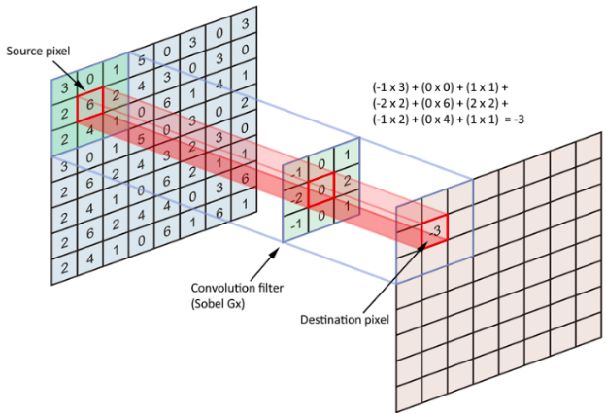dataset, similar to how we would.

Figure 6.1: Operation of Convolutional Layer

The above example illustrated the convolutional operation in 2D, but in reality convolutions are performed in 3D. Each image is namely represented as a 3D matrix with a dimension for width, height, and depth. Depth is a dimension because of the colours channels used in an image (RGB). Generally, numerous convolutions on the input is performed, where each operation uses a different filter. This results in different feature maps. In the end, we take all of these feature maps and put them together as the final output of the convolution layer.

1. **Batch Normalization Layer**

Training deep neural networks with tens of layers is challenging as they can be sensitive to the initial random weights and configuration of the learning algorithm. One possible reason for this difficulty is the distribution of the inputs to layers deep in the network may change after each mini-batch when the weights are updated. This can cause the learning algorithm to forever chase a moving target. This change in the distribution of inputs to layers in the network is referred to the technical name “internal covariate shift”.

Batch normalization is a technique for training very deep neural networks that standardizes the inputs to a layer for each mini-batch. This has the effect of stabilizing the learning process and dramatically reducing the number of training epochs required to train deep networks.

1. **Max Pooling Layer**

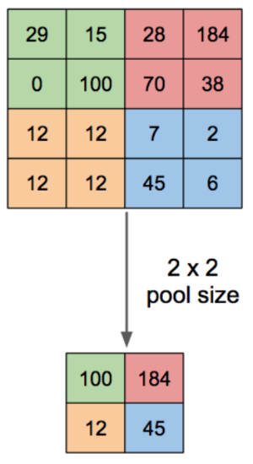

Figure 6.2: Max Pooling Operation

Similar to the Convolutional Layer, the Pooling layer is responsible for reducing the spatial size of the convolved feature. This is to *decrease the computational power required to process the data through dimensionality reduction*. Furthermore, it is useful for *extracting dominant features which are rotational and positional invariant*, thus maintaining the process of effectively training of the model.

Max Pooling also performs as a *Noise Suppressant*. It discards the noisy activations altogether and also performs de-noising along with dimensionality reduction. The Figure 6.2 illustrates the max pooling operation.

1. **Dropout Layer**

In machine learning, regularization is way to prevent over-fitting. Regularization reduces over-fitting by adding a penalty to the loss function. By adding this penalty, the model is trained such that it does not learn interdependent set of features weights. Dropout is an approach to regularization in neural networks which helps *reducing interdependent learning amongst the neurons*. It forces a neural network to learn more robust features that are useful in conjunction with many different random subsets of the other neurons. roughly doubles the number of iterations required to converge. However, training time for each epoch is less. The Figure 6.3 illustrates the operation of dropout.

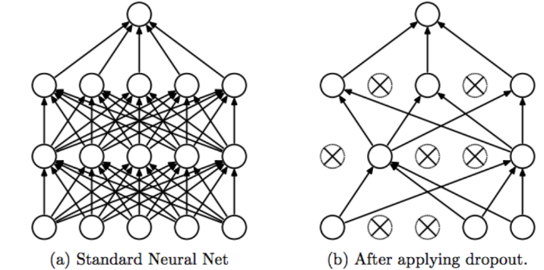

Figure 6.3: Operation of Dropout

1. **Fully Connected Layer**

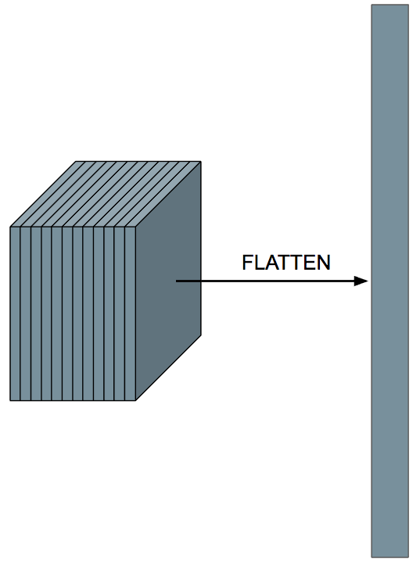 Adding a Fully-Connected layer is a (usually) cheap way of learning non-linear combinations of the high-level features as represented by the output of the convolutional layer. The Fully-Connected layer is learning a possibly non-linear function in that space. Now that we have converted our input image into a suitable form for our Multi-Level Perceptron, we shall flatten the image into a column vector. The flattened output is fed to a feed-forward neural network and backpropagation applied to every iteration of training. Over a series of epochs, the model is able to distinguish between dominating and certain low-level features in images and classify them using the *softmax* classification technique.

Figure 6.4: Fully Connected Layer

* 1. **Architecture of Proposed CNN**

The proposed CNN model consists of 20 layers. Which of them are Two-Dimensional Convolutional Layer (Conv2D), Batch Normalization Layer, Max Pooling Layer, Dense Layer. The architecture takes a gray scale image with shape *(100,100, 1)* and results the class label of the image as prediction.

Table 6.1: Architecture of Proposed CNN Model

|  |  |  |
| --- | --- | --- |
| **Layer** | **Output Shape** | **#parameters** |
| Conv2D | (None, 98, 98, 64) | 640 |
| BatchNormalization | (None, 98, 98, 64) | 256 |
| Conv2D_1 | (None, 96, 96, 64) | 36928 |
| BatchNormalization_1 | (None, 96, 96, 64) | 256 |
| Conv2D_2 | (None, 96, 96, 64) | 102464 |
| BatchNormalization_2 | (None, 96, 96, 64) | 256 |
| MaxPooling2D | (None, 48, 48, 64) | 0 |
| Dropout | (None, 48, 48, 64) | 0 |
| Conv2D_3 | (None, 46, 46, 128) | 73856 |
| BatchNormalization_3 | (None, 46, 46, 128) | 512 |
| Conv2D_4 | (None, 44, 44, 128) | 147584 |
| BatchNormalization_4 | (None, 44, 44, 128) | 512 |
| Conv2D_5 | (None, 44, 44, 128) | 409728 |
| BatchNormalization_5 | (None, 44, 44, 128) | 512 |
| MaxPooling2D_1 | (None, 22, 22, 128) | 0 |
| Dropout_1 | (None, 22, 22, 128) | 0 |
| Conv2D_6 | (None, 20, 20, 256) | 295168 |
| BatchNormalization_6 | (None, 20, 20, 256) | 1024 |
| MaxPooling2D_2 | (None, 10, 10, 256) | 0 |
| Dropout_2 | (None, 10, 10, 256) | 0 |
| Flatten | (None, 25600) | 0 |
| Dense | (None, 256) | 6553856 |
| BatchNormalization_7 | (None, 256) | 1024 |
| Dense_1 | (None, 128) | 32896 |
| BatchNormalization_8 | (None, 128) | 512 |
| Dense_2 | (None, 5) | 645 |

The total number of parameters of the CNN are *7,658,629* of which *7,656,197* are trainable and *2,43*2 are non-trainable. The detailed description of the architecture is shown in Table-6.1.

The two-dimensional convolutional layer is used to extract the features from the previous input, the batch normalization layer is used in order to normalize the input and also overcome the problem of vanishing gradient and exploding gradient. The max pooling layer is used to reduce the dimensionality of the input and the dropout layer is used to avoid the over fitting problem.

* 1. **Training the CNN**

The proposed Convolutional Neural Network (CNN) is trained on the data containing 4 classes. Which is divided in the ratio of 80:20 into *train* with 8524 samples and *test* with 1505 samples.

Figure 6.5: Accuracy and Loss of the CNN Model

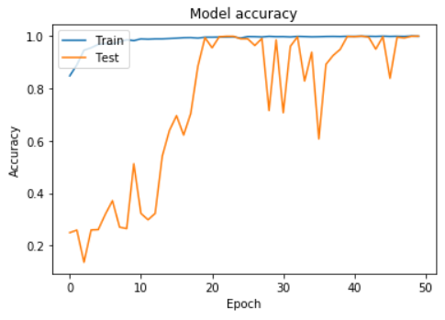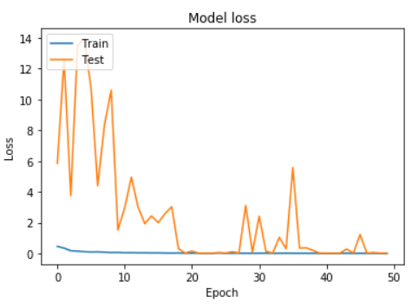

The following parameters are also used in training process:

* Optimizer – RMSProp
* Learning Rate – 0.001
* Loss Metric – Categorical Cross Entropy
* Batch Size – 256
* Epochs – 50

The accuracy and the loss of the CNN model during the training w.r.t number of epochs on *train* and *test* data are represented in Figure 6.5. It is evident that with increase in number of epochs the accuracy is increasing and loss is decreasing and at a certain number of epochs, both the loss and accuracy do not change further.

* 1. **Visualizing Output of Intermediate Convolutional Layers**

Training the CNN involves feeding forward your training data, generating predictions, and computing a loss score, which is used for optimization purposes. However, it may be the optimizer gets stuck after some time and It is needed to know why this occurs and, more importantly, the convolutional layers, which learn features from the image, that can be used by densely connected layers for classification purposes.

Especially with problems that are less straight-forward, CNNs can be tough to train. In some cases, it does not even converge. Visualizing layer outputs gets important in those cases. As convolutional layers, together with additional layers such as pooling layers down sample the image in the sense that it gets smaller and more abstract. When this happens, a neural network might no longer be able to discriminate between the classes, and hence show inadequate performance.

Visualising the features learned by the network helps to tune, since one can see an error made by the network and able to point out the cause directly. Furtherly, if the model performance is not improved, then extending and improving the overall design of the model can be helpful. Based on the knowledge of the current design, including the strengths and weaknesses of it. The intermediate layer visualizations of convolutional layers Conv2D_1, Conv2D_2, Conv2D_3, Conv2D _4, Conv2D_5 of the CNN model corresponding to an input image are shown in Fig-6.6.



Input

Conv2D_1

Conv2D_2

Conv2D_3

Conv2D_4

Figure 6.6: Intermediate Layer Visualisation of CNN

Conv2D_5

**6.6 Evaluating CNN Model**

Model evaluation metrics are required to quantify model performance. The choice of evaluation metrics depends on a given task (such as classification, regression, ranking, clustering, topic modelling, among others). Some metrics, such as precision-recall, are useful for multiple tasks. Supervised learning tasks such as classification and regression constitute a majority of applications. Let’s see some of the popular metrics to evaluate the model performance.

1. **Confusion Matrix**

A confusion matrix is a technique for summarizing the performance of a classification model. The number of correct and incorrect predictions are summarized with count values and broken down by each class. This is the key to the confusion matrix. The Figure 6.7 shows the interpretation of confusion matrix.

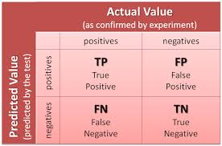

Figure 6.7: Explanation of Confusion Matrix

* True positives (TP): Predicted positive and are actually positive.
* False positives (FP): Predicted positive and are actually negative.
* True negatives (TN): Predicted negative and are actually negative.
* False negatives (FN): Predicted negative and are actually positive.

1. **Classification Accuracy**

Accuracy in classification problems is the number of correct predictions made by the model over all kinds predictions made. In the Numerator, are our correct predictions (True positives and True Negatives) and in the denominator, are the kind of all predictions made by the algorithm (Right as well as wrong ones).

$$Classification Accuracy = (TP+TN)/(TP+FP+FN+TN)$$

1. **Precision**

Precision is a valid choice of evaluation metric when we want to be very sure of our prediction.

$$Precision = (TP)/(TP+FP)$$

1. **Recall**

Another very useful measure is recall, which answers a different question: what proportion of actual Positives is correctly classified?

$$Recall = (TP)/(TP+FN)$$

1. **F1 Score**

The F1 score is a number between 0 and 1 and is the harmonic mean of precision and recall.

$$F1 Score = (2×Precision×Recall)/(Precision+Recall)$$

1. **Kappa Score**

Kappa Score a statistic that measures inter-annotator agreement. This is a function computes Cohen’s kappa, a score that expresses the level of agreement between two annotators on a classification problem. It is defined as

$$Κ =\frac{Po - Pe}{1 – Pe}$$

where $Po$ is the empirical probability of agreement on the label assigned to any sample (the observed agreement ratio), and $Pe$ is the expected agreement when both annotators assign labels randomly. $Pe$ is estimated using a per-annotator empirical prior over the class labels.

**CHAPTER - 7**

**IMPLEMENTATION**

T

he project proposes a facial recognition system using *Convolutional Neural Network (CNN).* The CNN implicitly extracts the features from the human faces and predicts the class for given human face which can be achieved through training and hyper parameter tuning of the proposed novel CNN. The project also aims to develop an end-to-end process to build a custom facial recognition system i.e. to deal with real time data. This section describes the proposed web-based application for attendance posting using face recognition using CNN, which is developed using *flask framework* and *python3.*

The main components of the application are:

* Front-end-interface (Camera)
* Server
* CNN model
* Database
* End result (Display)

1. **Front-End interface**

A simple web page which takes the video frame as input through the camera using *open computer vision (OpenCV)* library. The video frame that is taken as input is then sent to the server where already the novel *CNN* model is already dumped. It is to be noted that in the image returned form the front-end interface the location of the face is identified by the automated script and a new resized image fit for the input size of the model is formed.

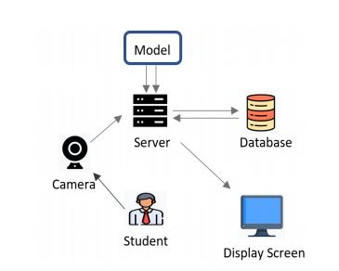

Figure 1: An overview of proposed application

1. S**erver**

The back-end of the application which maintains the connection with the front-end interface, model, database and display screen. The input frame that is taken from the front-end interface is processed to identify the face location and resize it accordingly to the input size for the model for prediction. The script and the model necessary for processing the image and providing the input to the model respectively are previously dumped into the server and a call is made accordingly whenever the application comes to running stage. Finally, the most important duty of the server is maintaining the database regarding information of existing faces as well as their posted attendance for a particular period.

1. **CNN model**

The novel *CNN model* developed for real-time datasets with high accuracy. It receives resized image that is obtained from the front-end interface as input and generates a label that is nearer to a face existing in the database.

1. **Database**

A database is created which maintains the details regarding details of students, their attendance including the timestamps. It becomes handy for the server to update, select values whenever and wherever necessary.

1. **End-result**

The end-result is a web page which includes the details of the student such as his/her name, registered number, period, status of attendance and timestamp.

**7.1 Working of the application**

As a beginner in machine learning, it might be easy for anyone to get enough resources about all the algorithms for machine learning and deep learning but when we start to look for references to deploy ML model to production, a very profitable solution is to use the very light web framework to deploy the successfully trained ML models as well as to create an API,(Application Programmable Interface). Flask framework is really flexible and handy to develop complete end-to-end web applications for any type of project and also very suggestible when deploying API’s for working of machine learning models.

Firstly, after running the application, the very first screen is the web page (**front-end interface)** that helps the user to capture the video frame. In the web page, a small button is highlighted, once after clicking it the video frame is processed to identify the location of the face in the frame and then it is resized for into to those dimensions that is fit for the input size of the developed *CNN model.* After successfully resizing the input frame, it is loaded to the model for making a prediction.

The *Flask* framework provides scope to import any package from python directly, so with this convenience we are going to import all the necessary packages for loading the model. Generally, a function namely **load_model** from the package TensorFlow is used to load the model. After loading the model, the resized image is fed to the model for processing to generate a label. The novel architecture of the proposed custom *CNN* model uses the classifier ***softmax,*** which is an activation function that turns number into probabilities that sum to one.

The CNN model outputs a vector that represents the probability distributions of a list of potential outcomes. Since the desired output is a single label related to only one of the trained faces, ***argmax*** function which helps in taking out the maximum of the probability distributions generated by *softmax.* Since the output from the *softmax* layer is a single dimensional vector, when it is passed to the *argmax* function the index of the maximum value is returned. From that index value, the server matches the existing label values with that of the generated index value and if there is a match, it posts all the details corresponding to that label in the form a web page containing the information such as status of attendance which includes Student Name, Registered Number, Period, Timestamp.

.

**CHAPTER - 8**

**RESULTS**

T

he experiment is conducted by using the data which contains 10,029 samples and the data is divided into *train* and *test* in order to train and evaluating the CNN model developed. The details of the *test* and *train* are shown in the Table 8.1. The experimental results of the CNN model and the web application which uses the developed novel CNN model is discussed.

Table 8.1: Details of Train and Test Data

|  |  |  |  |
| --- | --- | --- | --- |
| Data | Percentage | Samples |  |
| Train | 85% | 8524 |  |
| 4 | 15% | 1504 |  |

**8.1 CNN Model**

As it is a supervised learning task, Hence the evaluation of the CNN model is carried using the classification metrics such as Confusion Matrix, Precision, Recall, F1 Score and Kappa Score. The mentioned classification metrics are discussed in detail in the chapter – 6.

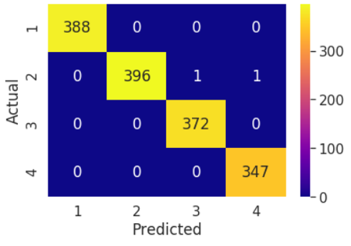

Figure 8.1: Confusion Matrix

* The *Confusion Matrix* is a table that is often used to describe the performance of a classification model on a set of test data.
* The class wise accuracy of the CNN model represents the classification accuracy of with respect to each class based on the predictions of the test data and it is represented in Table 8.2.

Table 8.2: Class-wise Accuracy

|  |  |
| --- | --- |
| Class Label | Accuracy |
| 1 | 100% |
| 2 | 99.49% |
| 3 | 100% |
| 4 | 100% |

* The different classification metrics such as Classification Accuracy, Precision, Recall, F1 Score and Kappa Score are used to evaluate the CNN model performance on the test or unseen data and the results are illustrated in the Table-8.3.

Table 8.3: Classification Metrics

|  |  |
| --- | --- |
| Metric | Value |
| Classification Accuracy | 99.8671% |
| Precision | 99.861% |
| Recall | 99.874% |
| F1 Score | 99.867% |
| Kappa Score | 99.822% |

* The Accuracy and the loss of the CNN model is 99.86% and 0.0019 and predictions samples of the images from the test data is shown in Figure 8.2.

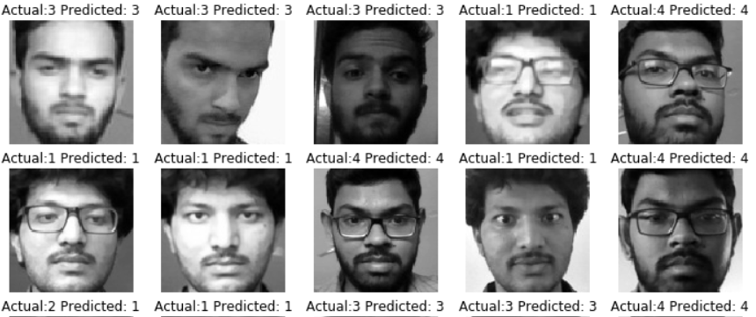

Figure 8.2: Predictions of Sample Test Images

**8.2 Web Application**

The web application is designed to post the attendance using the developed CNN model for face recognition. The web application posts the attendance into the database for the designated periods based on the timings of the college hours. The Figure 8.3 shows the screen shots of the web application which illustrates the capturing of the images and the end result of the application i.e., the status of the attendance is displayed



Figure 8.3: Web Application

**CONCLUSION**

The project formally introduces the role of Convolutional Neural Networks (CNNs) in Face Recognition and adaption of CNN in attendance posting and also proposes a *novel CNN architecture* for Face Recognition. The project also provides in detailed explanation on the key components which are essential to build a robust deep learning model, such as collecting real-time data i.e., Human Faces, Data Augmentation and Pre-Processing, Training and Hyper Parameter Tuning the proposed CNN model. Moreover, the project also provides a web application for attendance posting using Face Recognition by using the developed CNN model.

The *future scope* of the project is to build the dataset with more number of classes and to train the proposed CNN model as the project uses only four classes. To build a robust web application with different features such as Login Page, Attendance Management, Student Section, Faculty Section etc.

**REFERENCES**

**Papers:**

[1] S. Albawi, T. A. Mohammed, and S. Al-Zawi, “Understanding of a convolutional neural network,” in 2017 International Conference on Engineering and Technology (ICET). IEEE, 2017, pp. 1–6.

[2] G. Hu, Y. Yang, D. Yi, J. Kittler, W. Christmas, S. Z. Li, and T. Hospedales, “When face recognition meets with deep learning: an evaluation of convolutional neural networks for face recognition,” in Proceedings of the IEEE international conference on computer vision workshops, 2015, pp. 142–150.

[3] J. Redmon, S. Divvala, R. Girshick, and A. Farhadi, “You only look once: Unified, real-time object detection,” in Proceedings of the IEEE conference on computer vision and pattern recognition, 2016, pp. 779–788.

[4] A. Khan, A. Sohail, U. Zahoora, and A. S. Qureshi, “A survey of the recent architectures of deep convolutional neural networks,” arXiv preprint arXiv:1901.06032, 2019.

[5] A. El-Sawy, E.-B. Hazem, and M. Loey, “Cnn for handwritten Arabic digits recognition based on lenet-5,” in International conference on advanced intelligent systems and informatics. Springer, 2016, pp. 566–575.

[6] Z.-W. Yuan and J. Zhang, “Feature extraction and image retrieval based on alexnet,” in Eighth International Conference on Digital Image Processing (ICDIP 2016), vol. 10033. International Society for Optics and Photonics, 2016, p. 100330E.

[7] H. Qassim, A. Verma, and D. Feinzimer, “Compressed residual-vgg16 cnn model for big data places image recognition,” in 2018 IEEE 8th Annual Computing and Communication Workshop and Conference (CCWC). IEEE, 2018, pp. 169–175.

[8] K. Sun, Q. Zhao, J. Zou, and X. Ma, “Attendance and security system based on building video surveillance,” in International Conference on Smart City and Intelligent Building. Springer, 2018, pp. 153–162.

[9] M. Cos¸kun, A. Uc¸ar, O¨. Yildirim, and Y. Demir, “Face recognition based on convolutional neural network,” in 2017 International Conference on Modern Electrical and Energy Systems (MEES). IEEE, 2017, pp. 376–379.

[10] R. Fu, D. Wang, D. Li, and Z. Luo, “University classroom attendance based on deep learning,” in 2017 10th International Conference on Intelligent Computation Technology and Automation (ICICTA). IEEE, 2017, pp. 128–131.

[11] Z. Zhiyao and B. M. Di, “Multiplet selection: a practical study of multifaces recognition for student attendance system,” in Proceedings of the 2nd International Conference on Image and Graphics Processing, 2019, pp. 42–46.

[12] A. Mikołajczyk and M. Grochowski, “Data augmentation for improving deep learning in image classification problem,” in 2018 international interdisciplinary PhD workshop (IIPhDW). IEEE, 2018, pp. 117–122.

[13] L. Yuan, Z. Qu, Y. Zhao, H. Zhang, and Q. Nian, “A convolutional neural network based on tensorflow for face recognition,” in 2017 IEEE 2nd Advanced Information Technology, Electronic and Automation Control Conference (IAEAC). IEEE, 2017, pp. 525–529.

[14] J. Kolbusz, P. Rozycki, and B. M. Wilamowski, “The study of architecture mlp with linear neurons in order to eliminate the “vanishing gradient” problem,” in International Conference on Artificial Intelligence and Soft Computing. Springer, 2017, pp. 97–106.

[15] J. Kim, H. Kim et al., “An effective intrusion detection classifier using long short-term memory with gradient descent optimization,” in 2017 International Conference on Platform Technology and Service (PlatCon). IEEE, 2017, pp. 1–6.

[16] B. D. Eugenio and M. Glass, “The kappa statistic: A second look,” Computational linguistics, vol. 30, no. 1, pp. 95–101, 004.